

**AUTONOMOUS ROBOT**

**CHALLENGE**

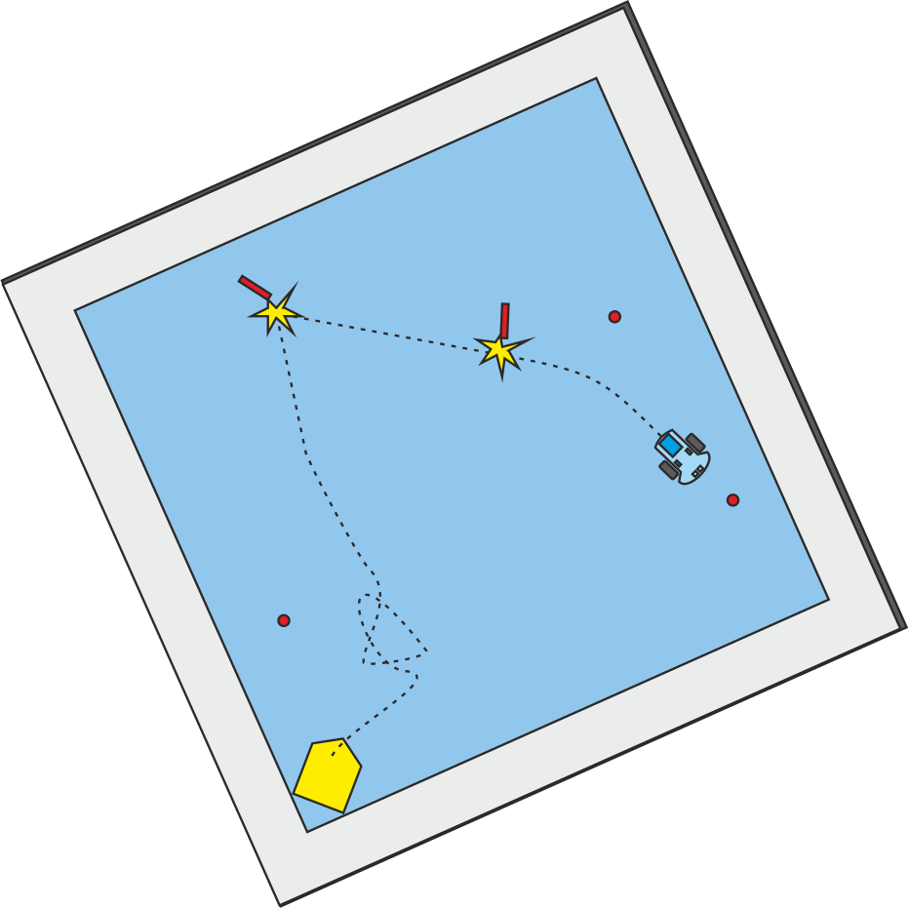

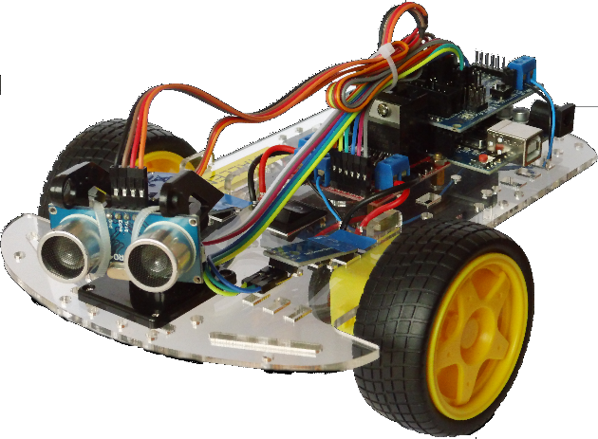

Some place - January 26

**The robot build has been completed. Now it's**

**up to you to show what you can let them do.**

**We have devised a challenge that requires**

**ingenuity, tactics and programming skills.**

**We dare you to compete against your**

**colleagues, alone or as a team, and see**

**who's robot does best.**

**The Challenge**

The challenge is to knock over 5 targets within

an area surrounded by “walls” as quickly as

possible without hitting the walls. You gain

points for knocking over targets but loose points

for hitting the walls. You can read all about it on

the back of this flyer.

**Lure**

As encouragement to participate, all

contestants will receive a small, but fun

addition to their robot. The winner(s)

earn eternal fame but as well as a

trophy and an even bigger addition

to their robot.

**Teams**

You don't have to enter the challenge alone. If

you team up with other contestants you can

combine your skills, divide the work and double

the fun.

**Programming and preparing**

There will be some time to program, prepare and

practice on the challenge evening. We expect

this to be too little time to complete all the work.

Devising a strategy and programming it beforehand

is advised.

**Modifications**

It is allowed to add extra balance weight to your

robot (see backside).

You are encouraged to “pimp” your robot and

make it pretty, funny or cool.

There will be an extra prize for the looks.

**Program**

|  |
| --- |
| 16:30 Welcome, explanation |
| 16:45 Program / prepare / practice |
| 18:30 Dinner (Pizza) |
| 19:00 Program / prepare / practice |
| 20:00 Challenge Time! |
| 21:00 Awards |

**Registration**

We are again using date finder to determine

the date. (*see mail*)

Organizer One

Organizer Two

We are looking forward to your participation!



**The Challenge is to knock over 5 targets**

**within an area surrounded by “walls” as**

**quickly as possible without hitting the walls.**

**You get points for knocking over the targets**

**but loose points for hitting the walls. There is**

**a time limit but time left after having knocked**

**over all targets grants you extra points.**

**Teams**

* Working in teams is encouraged.
* A team may enter 2 robots or one robot 2

times (of the 2 runs the best run counts).

* If a team wins all members win.

**Points**

* Knocking over a target 10 points
* Touching the wall -1 point.
* For every 6 seconds 1 point is subtracted.
* If all targets are knocked over the remaining
* time points will be added to the score.
* If a robot gets stuck against the walls it may be restarted at the launch pad. This will cost 5 points. Time will continue.



**Arena’s**

* The arena will be square 2.25 x 2.25 m.

with 15 cm high walls.

* There will be 5 targets 12.5 cm high,

1.6 cm across (like the one you got).

* Targets are placed at least 20 cm from the

edges and at least 20 cm from each other.

* The launch pad will be in one corner 20 cm

from the sides facing the opposite corner.

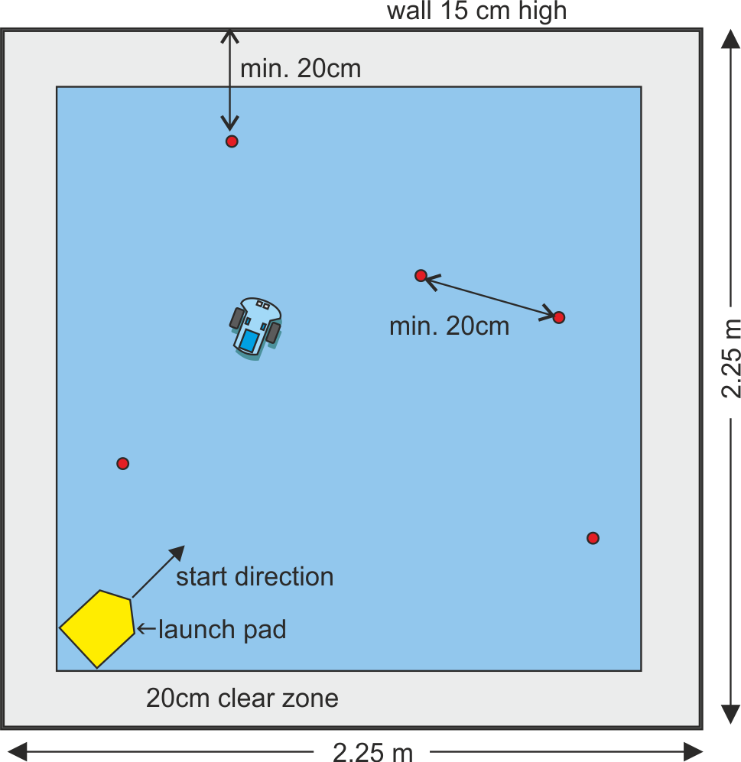

* There will be a time limit of 3 minutes.
* If all targets are knocked over time will stop.
* Each arena will have a referee. Robot

modifications need to be approved by the

referee.

* At the start a robot has 30 points for time.

**Modifications**

* The robot must consist of the original

components.

* You are encouraged to “pimp” your robot

and make it pretty, funny or cool. The

* additions can have no functional impact on

the challenge. (The robot may not be   
longer, wider or have extra moving parts to knock over targets).

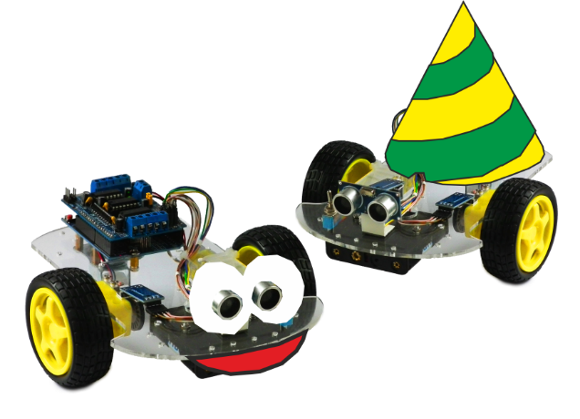

* There will be an *extra prize* for the coolest,

prettiest or funniest robot.

*Unforeseen matters are decided by the referees.*